Notes:
THE 7 “I AM” Sayings of Jesus

1. Jesus says, “I am the bread of life” (6:35). Spiritually hungry? Jesus is the bread of life.

2. Jesus says, “I am the light of the world” (8:12). Spiritually blind, groping around in the dark looking for meaning and enlightenment? Jesus is the light of the world.

3. Jesus says, “I am the door” (10:9). Seeking the door to salvation and to heaven? Jesus is the door.

4. Jesus says, “I am the Good Shepherd” (10:11). Wandering? Lost? Jesus is the Good Shepherd.

5. Jesus says, “I am the resurrection and the life”. Spiritually dead and dying? Fearing death? Jesus is the resurrection and the life.

6. Jesus says, “I am the way, and the truth, and the life” (14:6). Wondering what is the way? Unsure of the truth?

7. Jesus says, “I am the true vine” (15:1). Wanting to live a life of meaning and fruitfulness? Jesus is the true vine.

I am – eternal, preexistent, unchanging

"I am the LORD, and there is no other"
Isaiah 45:5

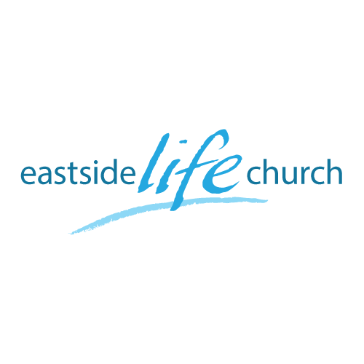
January 27th 2019

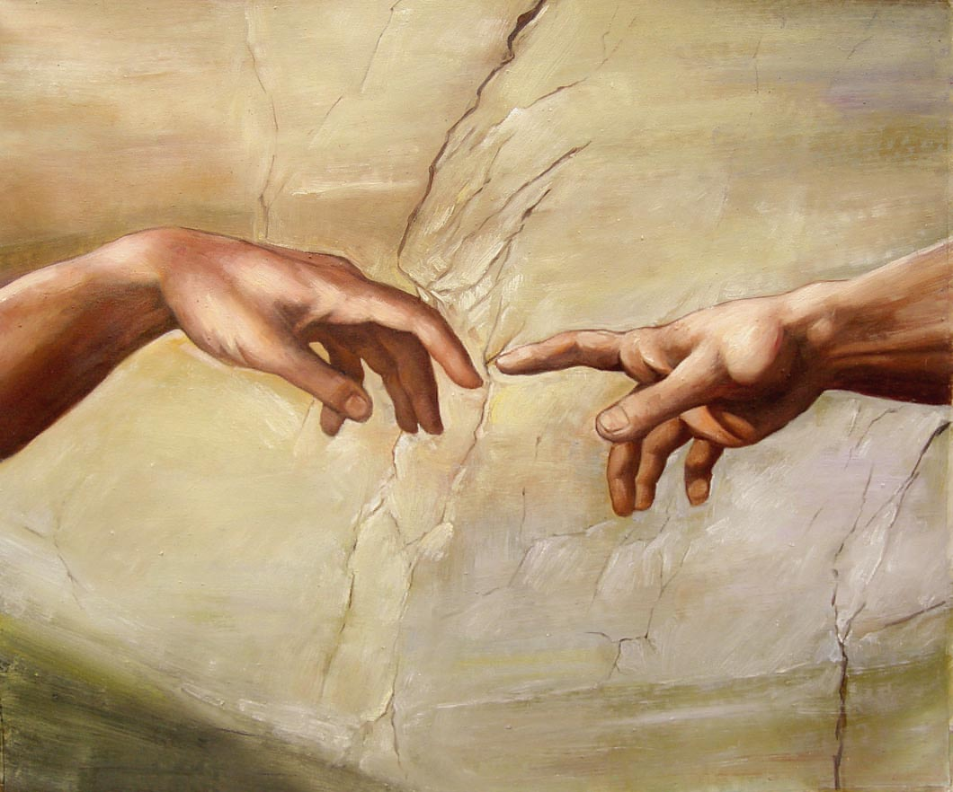

The Touch of God - 4
“God has not changed His mind”

Welcome
The first Sunday of the Rest (Best) of your life

2019

The Touch of God– Part 4
“God has not changed His mind”

Hebrews 13:8
Jesus Christ the same yesterday, and today, and forever.

See the pattern through time
(Consistent attitude towards sickness & disease)

If we can see God (Jesus) heal in the Old Testament, in Jesus time and then after He left, then we can conclude that it is in God’s nature to heal us.

Old Testament Example
2 Kings 5:1-19 - Naaman the leper

The servant girl’s role / Naaman’s pride / Eventual obedience.

In Jesus time: the central pivot
Salvation includes forgiveness and healing

John 1:1-2,14 / Exodus 15:26

Luke 5:17-26 – the paralytic gets healed

Timeline after Jesus had left
Peter had seen some stuff: because he had been with Jesus

Acts 3:1-8, - 4:13 - Presence of Jesus...power.

Miracle performed in the name of Jesus.

- God has not changed His mind about meeting people’s needs:
Sin – Disease – Sickness

Hebrews 13:8
Jesus Christ the same yesterday, and today, and forever.

Final take Away & Communion

‘Salvation’
Forgiveness, healing, deliverance
Is a complete package.

God saved us through what Jesus completed on our behalf.

‘Tetelestai’ – it is finished / completed.

