Notes:

February 3rd 2019

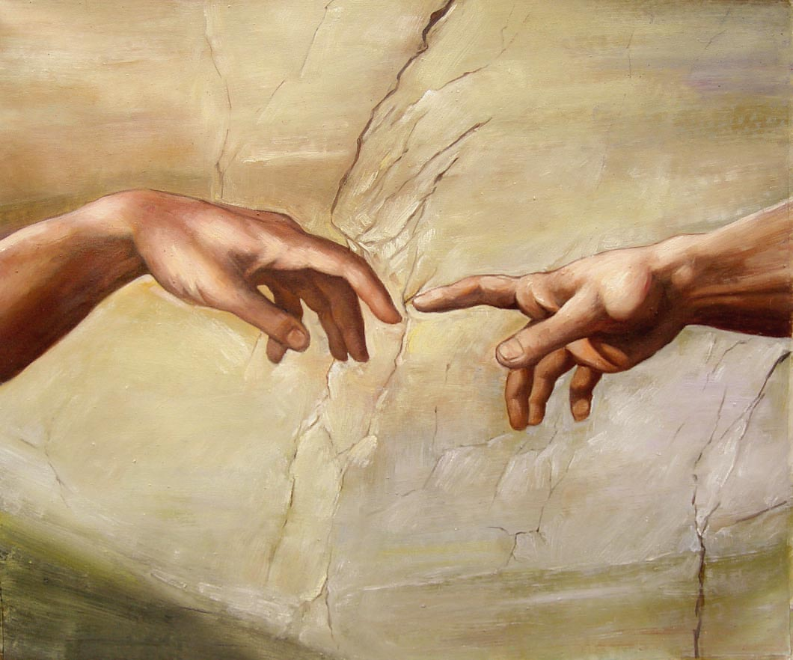

The Touch of God - 5
“Change your mind”

Welcome
The first Sunday of the Rest (Best) of your life

2019

The Touch of God– Part 5
“Change your mind”

Mark 1:15
The time is fulfilled, and the kingdom of God
is at hand: repent, and believe the gospel.
Repent: “ to turn (change your mind) after
the fact”
Gospel: “good news of Christ’s victory”

Can the pipe ‘clog’ up?

Matthew 10:8
Heal the sick, raise the dead, cleanse those who have leprosy, drive out demons. Freely you have received; freely give.

Let’s deal with a big root
Sin is not the root problem (says Jesus)

John 9:1
- Their reasoning focused on ‘sin’ as the root cause for the man’s blindness.
- Jesus focused on the goal of grace: heal the man!

Any reasoning must be with the Lord

Isaiah 1:18
"Come now, and let us reason together (settle the matter)," Says the LORD, "Though your sins are as scarlet, They will be as white as snow; Though they are red like crimson, They will be like wool.

Take whatever t5ime you need to settle the matter in the Word.

Psalm 119:130
The entrance of your words gives light; it gives understanding to the simple.

Barricades that get in the way
What ‘gets in the way’ of people receiving their healing?

2 Corinthians 10:4-5
The weapons of our warfare are not the weapons of the world. Instead, they have divine power to demolish strongholds. 5 We tear down arguments, and every presumption set up against the knowledge of God; and we take captive every thought to make it obedient to Christ.

We are responsible to “pull down strongholds”?

‘demolish’ - destroy / pull down
‘arguments’ – imaginations / speculations / reasonings
‘every presumption’ – high or lofty thing / proud obstacles / pretension

- Simply not knowing / ignorance. Hosea 4:6
- Unbelief: reluctance to let go of an opinion. Mark 6:5
- ‘Passivity’ – improper response to God’s sovereignty. Joshua 1:2-3
- Discouragement due to delays. Hebrews 6:12
- Bad experiences / circumstances in life: yours & family perhaps. Philippians 4:6-7

What to do today: Communion

‘Shred’ any cares or objections
Enthrone the higher reality of Jesus completed work @ the cross.

