Notes:

March 4th 2019

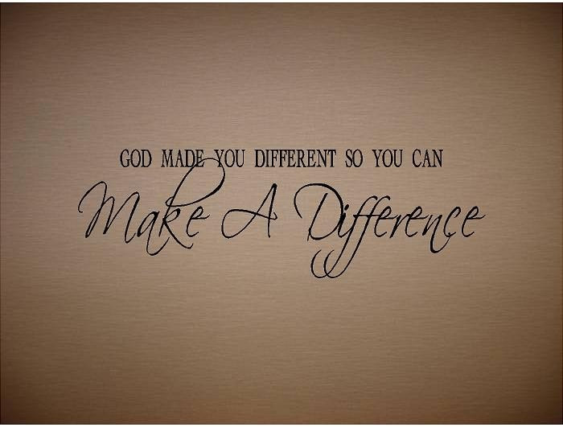

What difference does it make? Part - 1
“All the Difference”

Welcome
The first Sunday of the Rest (Best) of your life

2019

What difference does it make– Part 1
“All the difference”

Exodus 8:22-23
I will set apart the land of Goshen, in which My people dwell, that no swarms of flies shall be there, in order that you may know that I am the Lord in the midst of the land.
I will make a difference between My people and your people…

God’s got it covered
Things in the spirit, soul and the body

God makes a difference in meeting
“all” our personal needs

Psalm 103:1-3 (Under the Old Covenant even).
Bless the Lord, O my soul;
And all that is within me, bless His holy name!
² Bless the Lord, O my soul,
And forget not all His benefits:
³ Who forgives all your iniquities,
Who heals all your diseases,

Echo (from The Touch of God)
In Jesus ministry “all” were healed
Matthew 9:35

By the way, in Peter the disciple’s ministry:
(“all” were healed)
Acts 5:16

To reflect: Acts 10:38

Today, we live in the light of what Jesus
has done already: 1 Peter 2:24

God makes a difference
in protecting us in “all” things
(What He’s done for us)

Ephesians 1:19-23

Our part in spiritual warfare:
Ephesians 6:11,16 / 2 Corinthians 10:5

In the end,
God has a way of working things out for us:
Romans 8:28-30
²⁸ And we know that all things work together for good to those who love God, to those who are the called according to His purpose.

1 Peter 5:7
⁷ casting all your care upon Him, for He cares for you.

Final Take Away & Communion
My part in Communion

The cross made all the difference in the world

2 Corinthians 5:17-18
¹⁷ Therefore, if anyone is in Christ, he is a new creation; old things have passed away; behold, all things have become new.
¹⁸ Now all things are of God,

