Notes:

March 31st 2019

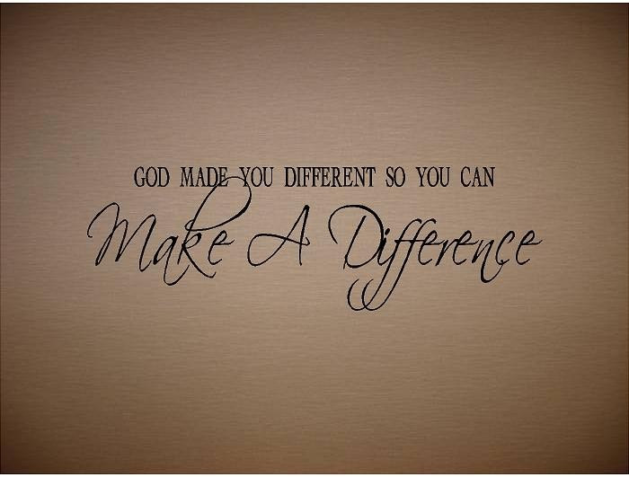

What difference does it make? Part - 4
“Hope”

Welcome
The first Sunday of the Rest (Best) of your life

2019

What difference does it make– Part 4
“Hope”

Hebrews 11:1,3
Now faith is the substance of things hoped for, the evidence of things not seen… (Note: with the natural eye)

Faith & hope are inseparably connected

Some hope facts

- Bible hope defined: (vs natural human hope).
“Confident expectation of good that God has promised”.

- Hope is one of the three cardinal spiritual ‘forces’ that ‘remain’: “faith, hope and love”

- God is the source of our hope:
“the God of hope will soon crush satan under our feet.”

Abraham’s story

Romans 4:16-18
Abraham, who is the father of us all…contrary to hope, in hope believed, so that he became the father of many nations, according to what was spoken, …

For our needs to be met today

- Find God’s promise in the Word that covers your need
(Read & Study)
- Meditate on it:
(Let it sink in)
- Declare it in faith out your mouth
(sets in motion the dynamic that activates God’s provision)

Fear as an example

2 Timothy 1:7
For God has not given us a spirit of fear, but of power and of love and of a sound mind.

- Personalize it by declare it as God’s word to you:
“Lord, you have not given me a spirit of fear, but have given me a spirit of power, love and soundness of mind.”

- Stand your ground and resist anything contrary to this.

Final Take Away & Communion

The hope we have in Christ is God’s gift to us that we celebrate in communion.

Jeremiah 29:11
For I know the thoughts that I think toward you, says the Lord, thoughts of peace and not of evil, to give you a future and a hope.

