Notes:
The 7 things Jesus said on the cross

A composite from 4 Gospels gives us
a picture of a complete savior

- Forgiveness: “Father forgive them, for they do not know what they do” – Luke 23:34

- Care for family: “When Jesus thereore saw His mother, and the disciple whom He loved standing by, He said to His mother, ‘Woman, behold your son!’ Then He said to the disciple, ‘Behold your mother!’ – John 19:25-27

- Reassurance to the penitent (thief): “ And Jesus said to him, ‘Assuredly, I say to you, today you will be with me in paradise.’”. – Luke 23:43

- Fulfillment: “After this, Jesus knowing that all things were now accomplished, that the scripture might be fulfilled, said, ‘I thirst’”. – John 19:28-29

- Cries out to God in despair: (identifies with ours) “’Eli, Eli, lama sabachthani?’ that is ‘My God, My God, why have you forsaken Me?’”. - Matthew 27:46-47

- Control in the midst of trauma: “So when Jesus had received the sour wine, He said, ‘It is finished!’. And bowing His head, He gave up His spirit.’” – John 19:30

- Trust: “And when Jesus had cried out with a loud voice, He said, ‘Father, into Your hands I commit My spirit’. Having said this, He breathed His last.” – Luke 23:45-46

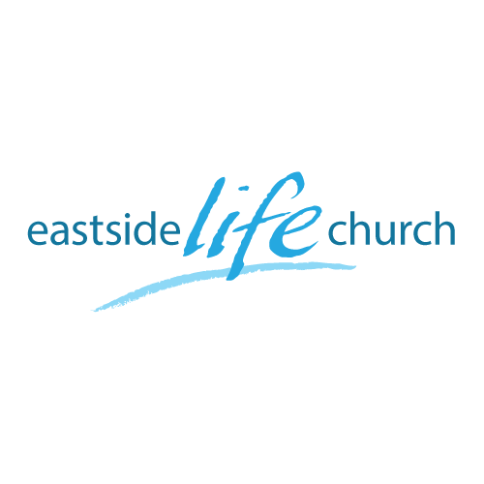
April 21st 2019

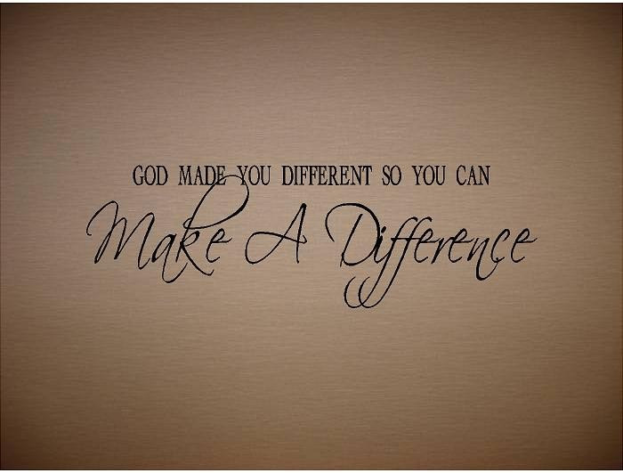

What difference does it make? Part - 7
“It is finished”

Welcome
Easter
2019

What difference does it make– Part 7 - Easter
“It is finished”

John 19:28, 30
Later, knowing that all was now completed , and so that the Scripture would be fulfilled , Jesus said, "I am thirsty"
... When he had received the drink, Jesus said,
"It is finished ”.
With that, he bowed his head and gave up his spirit."

“Tetelestai” – It is finished

- Jesus had finished the work the Father sent Him to do.

- The word tetelestai was the equivalent of the Hebrew word spoken by the high priest when he presented a sacrificial lamb without spot or blemish.

- The word tetelestai was used in the business world to sign off against a debt: “Paid in full”.

- In classical Greek times, the word tetelestai depicted a turning point when one period ended and another new period began.

So, if “it is finished”, (and Jesus paid it all)
what is there left for us to do?

Go live in the freedom from sin and it’s effects,…
…and tell the good news…

1 Peter 3:18a
For Christ also suffered once for sins, the righteous for the unrighteous, to bring you to God.

Final Take Away & Communion

Colossians 3:1,3 (Passion Translation)
1Christ’s resurrection is your resurrection too…

3Your crucifixion with Christ has severed the tie to this life, and now your true life is hidden away in God in Christ.

When Jesus died on the cross, He identified with what we did: (sin), and…

When Jesus rose from the dead we identify with what He did: (righteousness).

