Notes:

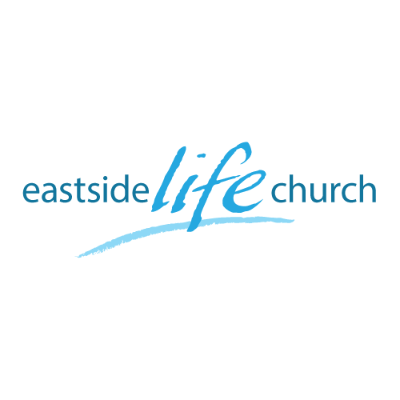
June 2nd. 2019

Eternity
“Resurrection”

Welcome
The first Sunday of the Rest (Best) of your life

2019

Eternity
“Resurrection”

Ecclesiastes 3:11
¹¹ He has made everything appropriate in its time. He has also set eternity in their heart…

Worship is central

Psalm 2:12
New Testament:
Original Greek Word: προσκυνέω
Transliteration: proskuneó
Definition: to do reverence to, adore
Usage: I go down on my knees to, prostrate oneself, do obeisance to, worship.
John 4:23
Not feigning but true worship & intimacy, kiss.

Wonderful Resurrection News

John 11:17-26 I am the resurrection and the life.

Do our bodies count in the long haul?

1 Corinthians 15:1…

Backdrop

God created us to live forever… Genesis 1:26-27
Sin introduced decay and ‘death’. Genesis 2:15
“Dying you shall die”
God set his plan of redemption and restoration in motion:
Redemption - buying us back from under satan’s dominion.
Restoration to eternal sonship – our authority under Jesus
Involves: spirit (pneuma) – soul (psuche) & body (soma).
(Resurrection is the final key aspect where ‘death is defeated’).

What about “long life”

Genesis 6:3
And the Lord said, “My Spirit shall not strive with man forever, for he is indeed flesh; yet his days shall be one hundred and twenty years.”
Psalm 90:10
The days of our lives are seventy years;
And if by reason of strength they are eighty years,

Can years be ‘added’?

Proverbs 3:1-2 – the promise
Proverbs 4:20-22 – the mechanism

All because of God’s work @ the cross

Right now - we can enjoy abundant life - 3 John 2

In the future: the resurrection of our bodies -1 Cor 15:52

Powerful Encouraging Promise

Romans 8:11 But if the Spirit of Him who raised Jesus from the dead dwells in you, (and He does)
He who raised Christ from the dead will also give life to your mortal bodies through His Spirit who dwells in you.

Communion

1 Corinthians 11:27-32 – living out your days.

Properly discern Christ’s body.

