Notes:

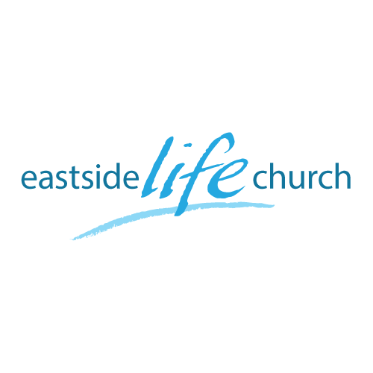
June 23^{rd.} 2019

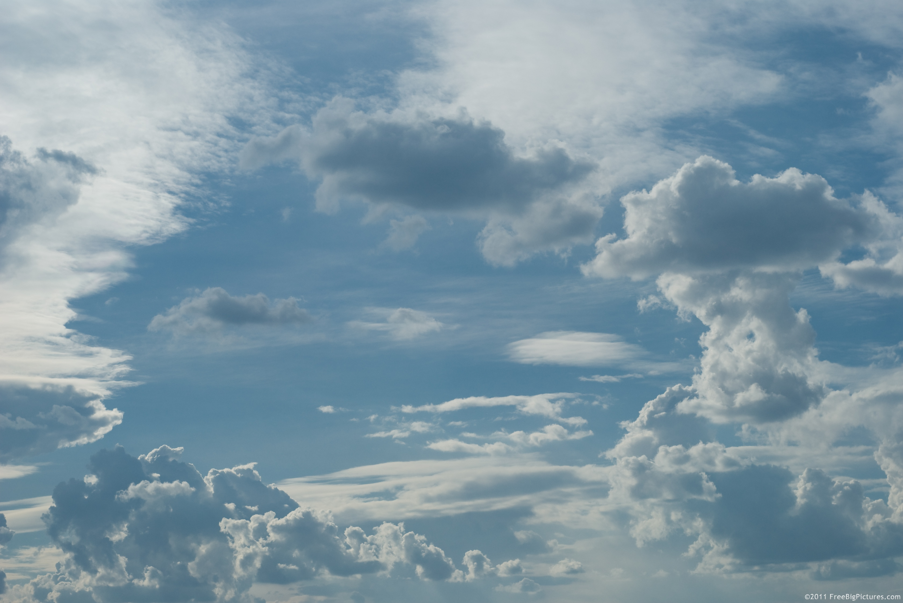

Eternity
“The Eternal City”

Welcome
The first Sunday of the Rest (Best) of your life

2019

Eternity
“The Eternal City”

Ecclesiastes 3:11
¹¹ He has made everything appropriate in its time. He has also set eternity in their heart…

Our Father in heaven wants us to see things from His perspective.
Why? Because we don’t always see things right.

Colossians 3:2-17
Set your mind on things above, not on things on the earth. ³ For you died, and your life is hidden with Christ in God. ⁴ When Christ who is our life appears, then you also will appear with Him in glory.

Jerusalem is the most significant Old Testament City

Melchizedek / Abraham / King David

Jerusalem at Pentecost Outpouring
(God’s heart for the lost)

Acts 2:5-6
And there were dwelling in Jerusalem Jews, devout men, from every nation under heaven.

Always been God’s plan to reach all people
Genesis 12:1-3 / Isaiah 49:6 / Mark 16:15

God’s goodness attracts Isaiah 60:1-3

Example in OT: 1 Kings 10:1,4 – Queen of Sheba

The heavenly city of God - future

What’s in it and what’s not.
Read Revelation.
Your heavenly mansion: John 14:2
In My Father’s house are many mansions; if it were not so, I would have told you. I go to prepare a place for you.

The river that flows: Revelation 22:22
Then the angel showed me the river of the water of life, as clear as crystal, flowing from the throne of God and of the Lamb 2 down the middle of the great street of the city. On each side of the river stood the tree of life, bearing twelve crops of fruit, …

Communion

God’s river of blessing has power to break through to any need.

2 Samuel 5:20
“The Lord has broken through my enemies before me,
like a breakthrough of water.”

