Notes:

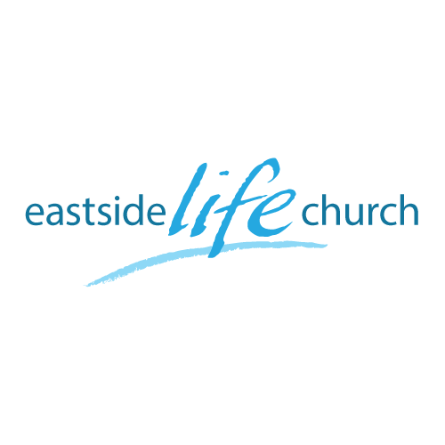
June 16th. 2019

Eternity
“The Father’s Heart”

Welcome
The first Sunday of the Rest (Best) of your life

2019

Eternity
“The Father’s Heart”

Ecclesiastes 3:11
¹¹ He has made everything appropriate in its time. He has also set eternity in their heart…

Our Father in heaven wants us to see things from His perspective.
Why? Because we don’t always see things right.

Jesus came to reveal heaven’s perspective
of the Father Heart of God

John 14:9 …he that has seen me has seen the Father;
John 5:19-20 Then Jesus answered and said to them, “Most assuredly, I say to you, the Son can do nothing of Himself, but what He sees the Father do; …

Our Father invites us to ‘see’
with a renewed mind

Our part: ‘Put off’ the old man (carnal way thinking)
‘Put on’ the new man (God way of thinking)

Ephesian 4:20-23
…you have heard Him and have been taught by Him, as the truth is in Jesus: ²² that you put off, concerning your former conduct, the old man which grows corrupt according to the deceitful lusts, ²³ and be renewed in the spirit of your mind, ²⁴ and that you put on the new man which was created according to God, in true righteousness and holiness.

Our Father’s heart is to cast light
on who we really are as covenant people

Joshua & Caleb’s mindset Vs majority ‘consensus’.
Numbers 13:30-33 – “grasshoppers in our own sight”.
Connecting Scriptures

Matthew 6:22-23 / Joshua 1:8

King David’s example

Psalm 39:1-4
While I was musing, the fire burned. (‘meditating’ / Hagah)
Then I spoke with my tongue:

Jesus gives us

Eyesight – see things as they really are
Insight – wisdom to live in a mixed up world
Foresight – prophetic vision
Hindsight – reflect on the past according to the Word.

Psalm 32:8
I will instruct you and teach you in the way which you shall go: I will guide you with my eye. (His perspective)

Communion
The Father’s heart: our total well-being:

3 John 2
Beloved, I pray that you may prosper in all things
and be in health,
just as your soul prospers.

Jesus body torn: for our ‘outer’ well being
His blood shed: for our ‘inner’ well being

