Notes:

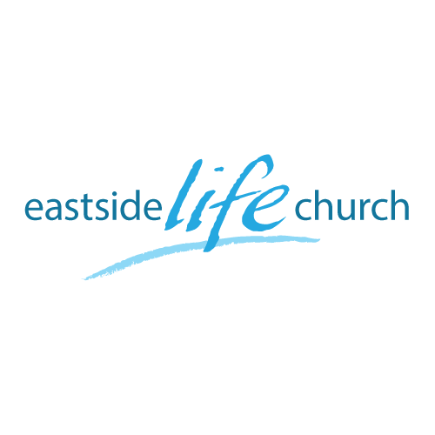

July 21^{st.} 2019

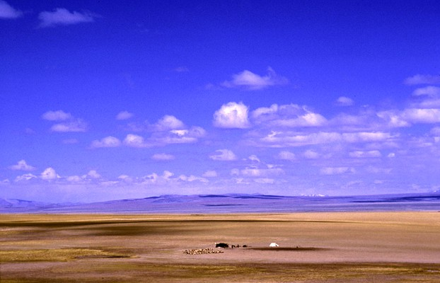

Wide Open Spaces - 1
“Wide Open Spaces”

Welcome
2019

Wide Open Spaces - 1

‘Wide open Spaces’

Romans 5:2 (Message Bible)
We throw open our doors to God and discover at the same moment that he has already thrown open his door to us. We find ourselves standing where we always hoped we might stand - out in the wide open spaces of God's grace and glory, standing tall and shouting our praise.

‘Constricted’
It’s no fun

Physically / mentally / spiritually

Thankfully Jesus confronted these:

Physical: woman bent over in Luke 13:11
Mental: unbelief that limits God in Psalm 78:41
Spiritual: scribes & pharisees in Matt 23:1-12

Galatians 5:1 (NIV)
“It is for freedom that Christ has set us free”

Freedom from …freedom to
Live life to His glory in the wide open spaces of grace.

Made alive in Christ

Ephesians 1:1-5 – made alive
1 And you He made alive, who were dead in trespasses and sins,
John 8:36 – free indeed.
“Therefore if the Son makes you free, you shall be free indeed”.

If you have Christ, you have everything you need.

Colossians 2:9-10
For in Him dwells all the fullness of the Godhead bodily; ¹⁰ and you are complete in Him,

Then what?
First step walking in Jesus’ footsteps
“Declare in faith who you really are in Him”

As we follow in His footsteps we declare who we are …in Christ.

All that He has done and given us by grace through faith.

Examples:
- God has given me a spirit of power, love and a sound mind:
2 Timothy 1:7
- God has made me to be His righteousness:
2 Corinthians 5:17-21
- All things that pertain to life and godliness:
2 Peter 1:3-4

Communion

Jesus’ forgiveness breaks us into a wide space of freedom,
And then also to break us free from the oppression of sickness

Acts 10:38
…how God anointed Jesus of Nazareth with the Holy Spirit and with power, who went about doing good and healing all who were oppressed by the devil, for God was with Him.

