Notes:

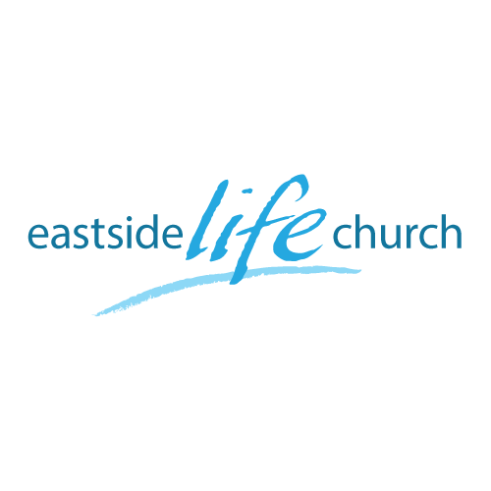
August 18th. 2019

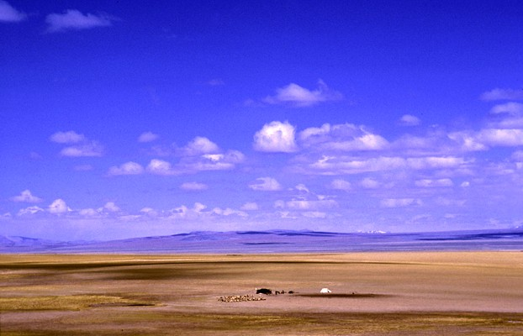

Wide Open Spaces - 5
“When God Speaks”

Welcome
2019

Wide Open Spaces - 5

‘When God Speaks’

Romans 5:2 (Message Bible)
We throw open our doors to God and discover at the same moment that he has already thrown open his door to us. We find ourselves standing where we always hoped we might stand - out in the wide open spaces of God's grace and glory, standing tall and shouting our praise.

The Tacoma Narrows Bridge Collapse
The role of sound and airflow

Resonance and the Millennium footbridge in London, England.

Jericho and the big wall collapse

Joshua 6:20
²⁰ So the people shouted when the priests blew the trumpets. And it happened when the people heard the sound of the trumpet, and the people shouted with a great shout, that the wall fell down flat.

All things hold together??

Colossians 1:17
And he is before all things, and by him all things are held together.

How exactly…perhaps by means of the sound of His voice!?

Hebrews 1:3
^{… 3} who being the brightness of His glory and the express image of His person, and upholding all things by the word of His power, when He had by Himself purged our sins, sat down at the right hand of the Majesty on high,…

God and Words

Isaiah 55:8-11
…
¹¹ So shall My word be that goes forth from My mouth;
It shall not return to Me void,
But it shall accomplish what I please,
And it shall prosper in the thing for which I sent it.

Words and Prayer

Mark 11:22-25 / John 15:7 / 1 John 5:14-15

His word is His will

Hearing God’s Voice

John 10:27
²⁷ My sheep hear My voice, and I know them, and they follow Me.

Psalm 23:
The Lord (is) my shepherd;
I shall not want …

