Notes:

September 8th. 2019

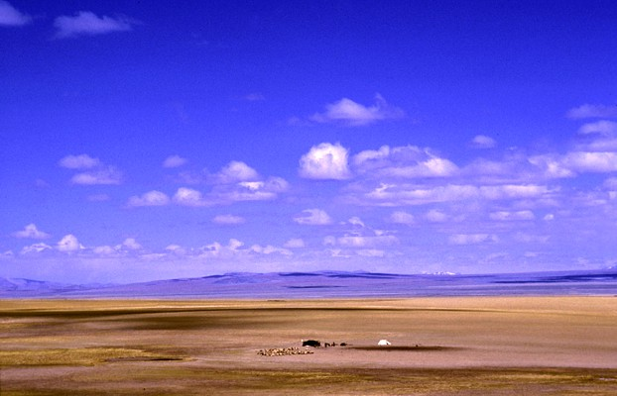

Wide Open Spaces - 7
“Q& A”

Welcome
2019

Wide Open Spaces - 7

‘Q & A’

Our base Text:

Romans 5:2 (Message Bible)
We throw open our doors to God and discover at the same moment that he has already thrown open his door to us. We find ourselves standing where we always hoped we might stand - out in the wide open spaces of God's grace and glory, standing tall and shouting our praise.

Ephesians 2:8-10
⁸ For by grace you have been saved through faith, and that not of yourselves; it is the gift of God, ⁹ not of works, lest anyone should boast.
¹⁰ For we are His workmanship, created in Christ Jesus for good works, which God prepared beforehand (His part – sovereign initiation) that we should walk in them (our part – faith & obedience response).

Pointers to consider

‘Person’ or ‘System’
Jesus or Moses?
Too much grace?
License to sin?
Law or grace?
Confession of Lordship or sin?

Key Scriptures

John 1:14
Hebrews 1:1-3
2 Corinthians 5:17-21
Ephesians 2:8-10
Romans 5:17
John 1:29
Ephesians 1:7
Colossians 1:13-14

God’s plan for man

“To redeem and restore us to full and fruitful sonship through the gift of His Son Jesus Christ our Lord’s completed work at the cross”.

At the very last moment

Luke 23:40-43
⁴⁰ But the other, answering, rebuked him, saying, “Do you not even fear God, seeing you are under the same condemnation? ⁴¹ And we indeed justly, for we receive the due reward of our deeds; but this Man has done nothing wrong.”
⁴² Then he said to Jesus, “Lord, remember me when You come into Your kingdom.”
⁴³ And Jesus said to him, “Assuredly, I say to you, today you will be with Me in Paradise.”

What opportunity did the thief have to be a good Calvinist?

