Notes:

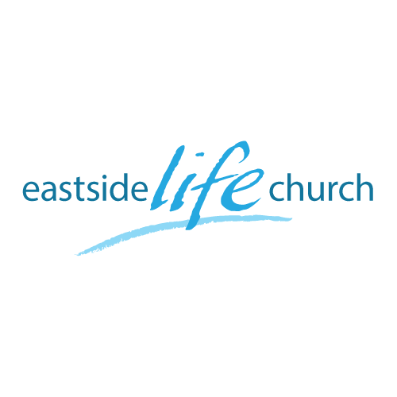
October 6th. 2019

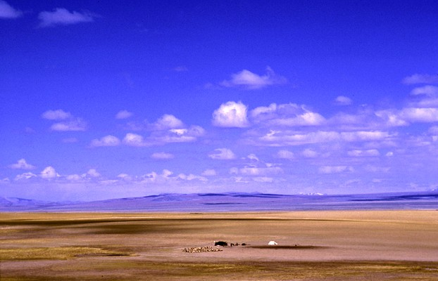

Wide Open Spaces - 10
“What if ?”

Welcome
2019

Wide Open Spaces - 10

‘What if?’

Romans 5:2 (Message Bible)
We throw open our doors to God and discover at the same moment that he has already thrown open his door to us. We find ourselves standing where we always hoped we might stand - out in the wide open spaces of God's grace and glory, standing tall and shouting our praise.

Report back

- All of heaven’s resources are ours.
(That you know of, believe and receive by faith).
Matthew 6:9-10
- End time characteristic: ‘visions and dreams’
Acts 2:17
- So dream (like a child): Matthew 18:3
Dreaming precipitates hope so that your faith can have something to ‘attach’ to. Hebrews 11:1
- Living in hope is evidence of the renewed mind Vs a foreboding spirit of bad things to come. Romans 15:13

The Power of Testimony

Revelation 12:10-11

- Your testimony is a ‘weapon’ – it causes you (and others) to overcome the adversary.
- Small or big, recent or long ago, there is power in your testimony.
- Testimonies must not be neglected but spoken out
– they still carry God’s backing (anointing).

Israel’s testimony of God’s faithfulness

Psalm 78: 1-4 – telling to the generation to come
Psalm 78:6-7 – set their hope in God.

Example: God brought them out to bring them in.

Psalm 78: 12-16 & Psalm 78:54- 55

All this despite many, many moments of faithlessness:
Psalm 78:56-58

Pointers

- God is patient but does not lower His standards
Blood sacrifice then, and now (Jesus) covered and cleansed.
- God’s overarching purposes will be achieved
We are always invited to be in on them.

