Raise a Hallelujah
[Verse 1
I raise a hallelujah, in the presence of my enemies
I raise a hallelujah, louder than the unbelief
I raise a hallelujah, my weapon is a melody
I raise a hallelujah, heaven comes to fight for me
Chorus
I'm gonna sing, in the middle of the storm
Louder and louder, you're gonna hear my praises roar
Up from the ashes, hope will arise
Death is defeated, the King is alive!
[Verse 2:
I raise a hallelujah, with everything inside of me
I raise a hallelujah, I will watch the darkness flee
I raise a hallelujah, in the middle of the mystery
I raise a hallelujah, fear you lost your hold on me!

Bridge
Sing a little louder (Sing a little louder) 3 X
Let's sing a little louder (Let's sing a little louder)
Sing a little louder (In the presence of my enemies)
Sing a little louder (Louder than the unbelief)
Sing a little louder (My weapon is a melody)
Sing a little louder (Heaven comes to fight for me)
Sing a little louder (In the presence of my enemies)
Sing a little louder (Louder than the unbelief)
Sing a little louder (My weapon is a melody)
Let's sing a little louder (Heaven comes to fight for me)
Sing a little louder!!

Chorus
I'm gonna sing, in the middle of the storm
Louder and louder, you're gonna hear my praises roar
Up from the ashes, hope will arise
Death is defeated, the King is alive!
Oh, I'm gonna sing, in the middle of the storm
Louder and louder, you're gonna hear my praises roar
Up from the ashes, hope will arise
Death is defeated, the King is alive!

October 20th. 2019

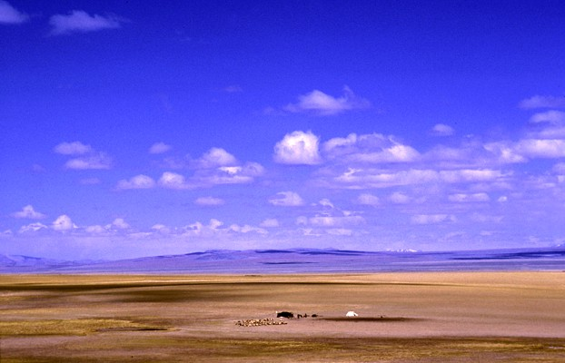

Wide Open Spaces - 12
“The Transformed Life ”

Welcome
2019

Wide Open Spaces - 12

‘The Transformed Life?’

Romans 5:2 (Message Bible)
We throw open our doors to God and discover at the same moment that he has already thrown open his door to us. We find ourselves standing where we always hoped we might stand - out in the wide open spaces of God's grace and glory, standing tall and shouting our praise.

The Power of Testimony

Revelation 12:10-11
¹⁰ Then I heard a loud voice saying in heaven, “Now salvation, and strength, and the kingdom of our God, and the power of His Christ have come, for the accuser of our brethren, who accused them before our God day and night, has been cast down. ¹¹ And they overcame him by the blood of the Lamb and by the word of their testimony, and they did not love their lives to the death.

Testimonies rehearse God’s power
Testimony: a public profession of a religious experience.”

- They are like a spiritual ‘weapon’ – it causes you to overcome the adversary
-No matter how ‘small’ or how long ago.
- Testimonies must not be neglected but spoken out.
-As they still carry God’s backing (anointing).

OT: Israel’s testimony of God’s faithfulness

Psalm 78: 1-4
Telling to the generation to come (testimony) the praises of the Lord,
And His strength and His wonderful works that He has done.

Psalm 78:6-7
⁷ That they may set their hope in God,…

Obedience & walking in His ways connect to hope.

Amazing grace:
God is faithful to them despite their frequent unfaithfulness
(lack of perfection)

Paul’s New Testament Example
(Damascus Road encounter)

2 Corinthians 5:17
Therefore, if anyone is in Christ, he is a new creation; old things have passed away; behold, all things have become new.

Paul testifies before the Jews in Jerusalem - Acts 22:1-16

Application today

We are transformed by beholding Jesus - 2 Corinthians 3:18
-Presence vs Principles

Beautiful picture of the preeminence of Jesus – Matthew 17:1-8
-Focus on Jesus completed work on our behalf.

