Notes

October 27th. 2019

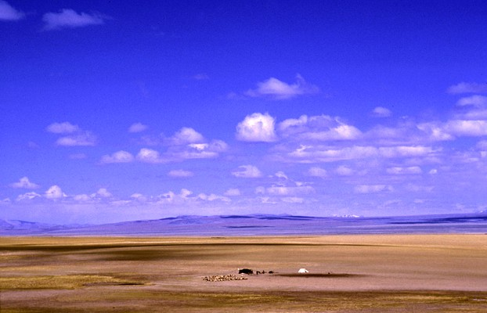

Wide Open Spaces - 13
“Stand Firm in your Freedom”

Welcome
2019

Wide Open Spaces - 13

‘Stand firm in your Freedom’

Romans 5:2 (Message Bible)
We throw open our doors to God and discover at the same moment that he has already thrown open his door to us. We find ourselves standing where we always hoped we might stand - out in the wide open spaces of God's grace and glory, standing tall and shouting our praise.

Galatians 5:1 (NIV)
It is for freedom that Christ has set us free.
Stand firm, then, and do not let yourselves be burdened again by a yoke of slavery.

Over time things change…
…if you don’t make a point of standing firm.

Paul was in religious bandage, got set free through an encounter with Jesus, and yet had to stand firm to maintain his freedom.

What is true Christian freedom anyway?
Is it freedom to do as we please because God will (has) forgiven us anyway?

Letter to the Galatians:
(Paul reflects the Lord’s
‘protective’ heart)
Galatians 1:6-7

Different gospels?
Perversions of the Gospel?
Do we live in a time where this sort of issue is a danger?

Paul’s religious advancement led to him persecuting the church.
Galatians 1:13-14

Paul relays the testimony to the radical transformation a relationship with Jesus had. Galatians 1:23

Paul speaks of ‘false brethren’ sent to bring them back into ‘bondage - Galatians 2:4-5

Example: when ‘little’ becomes ‘much’ - Galatians 2:11-13

Application
(the ‘little’ areas)

Ask the Lord to show you in what little areas
you may not be walking in the freedom that Christ has purchased for you.

In what areas do you feel the need to do something to please the Lord.

Remember it is impossible to please God …without faith

Hebrews 11:6
⁶ But without faith it is impossible to please Him, …

