Notes

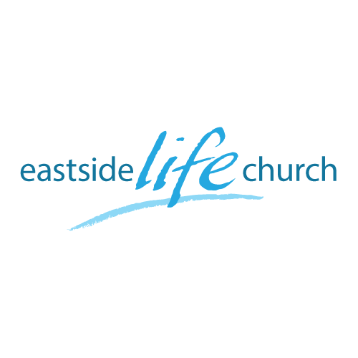
December 15th 2019

It’s beginning to look like Christmas – Part 2
“Priests”

Welcome
2019

It’s beginning to look like
Christmas – Part 2: Priests

Connecting some Christmas dots

High Priest, ‘regular’ priests, a tabernacle – place of meeting and blood sacrifices:
You could only get up close to God because of the blood.
Jesus presented to the Lord
After 40 days

Luke 2:22,24 … and to offer a sacrifice according to what is said in the law of the Lord, “A pair of turtledoves or two young pigeons.”

- The priests who officiated were of the Order of Aaron the High Priest under Moses.

- Jesus was born @ Christmas !? and grew up to be a priest, (…but not any ‘ol priest)

Hebrews 7:17 And the psalmist pointed this out when he prophesied, “You are a priest forever in the order of Melchizedek.”

- Under Aaron, the High Priest had to be replaced over and over.

The High Priest

- Back then, the whole nation’s standing with God depended on the High Priest’s sacrifice once a year @ atonement.
- Today, we (all believer's worldwide) depend on Jesus ‘standing with God for our security.

- Jesus sacrifice of blood on the cross (as High Priest) was unique.
- His blood needed to be shed only once for all, and then He sat down, indicating the sacrifices were finished.

Hebrews 7:27 / Hebrews 9:24-28 / Hebrews 10:12,14

Communion
(Back to Christmas)

So, what’s left for us to do?

As ‘priests’ to draw near and offer a sacrifice of praise (incense)
to Jesus…for His love, forgiveness and healing

