Notes

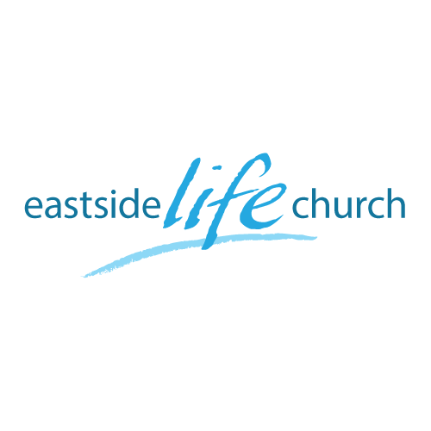
December 1st 2019

Stand Firm – Part 4
“Kings & Priests”

Welcome
2019

Stand Firm – Part 4
Galatians 5:1

Kings & Priests

God calls ordinary & extraordinary people to impact the world.
From the past and more recent.

Sphere’s of Influence

God’s people are called to influence: Family / Media / Politics / Business / Education / Entertainment / Sports / Religion

2 Corinthians 5:17-21
¹⁷ Therefore, if anyone is in Christ, he is a new creation; old things have passed away; behold, all things have become new.
¹⁸ Now all things are of God, who has reconciled us to Himself through Jesus Christ, and has given us the ministry of reconciliation…

Called to be kings and priests

1 Peter 2:9 – Peter calls us a ‘royal priesthood’ / ‘special’
Exodus 19 – the idea has ben around since Moses’ time on Mt Sinai
Intimacy / Authority / Law / Grace

Moses – cold hard commandments Vs Jesus heart matters in His beatitudes in the sermon on the mount.

With confession is the focus on sin or on what Christ has done for us to deliver us from sin?
Is Christianity a ‘to do list’ or simple abiding ‘intimacy’ with God which produces fruits of righteousness.

Communion

Jesus has redeemed us from the ‘curse’ of the Law
Galatians 3:13

(If you broke one you broke them all, and came under judgement)

