Notes

January 12th 2020

What time is it? - 2
“What do You See”

Welcome
January
2020

What time is it? – 2
“What do You see?”

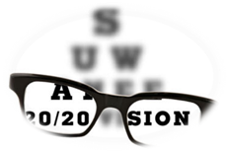

1 Chronicles 12:32
…of the sons of Issachar who had understanding of the times,
to know what Israel ought to do, …

Time to remember … and to forget.

The time we live in
“The last days”

Acts 2:17-18 – visions, dreams, prophecy are characteristic and ‘normal’.

What do you see? – with your inner man.

We need God to ‘enlighten our eyes’ - Ephesians 1:18

God’s sovereignty, speaking, seeing

Jeremiah’s story…and ours. Jeremiah 1:4-12

God’s calling speaks of sovereignty.
Don’t talk yourself out of your destiny.
Let God touch your mouth.
Look and see.

We cooperate with God as we ‘prophesy’ our future

John 16:13 – The Holy Spirit will show you things to come that affect you.

As our Father: God is intent on raising us up as ‘kings and priests’.
- Priests draw near to hear and see.
- Kings declare and decree.

Prophecy has a vital role in our victory over contrary circumstances. 1 Timothy 1:18-20

Communion

Luke 24:45
Then He opened their minds to understand the Scriptures,

Communion with The Lord opens our ‘eyes’.

